**Project 1**

In this project, you will need to decode the received signal by writing a program in any language you like.

The received signal can be found also on Canvas. The file name is pj1_testsignal1. In the file, each line is a single number representing the amplitude of one sample, where samples are taken at 2 microsecond intervals.

As we discussed in the class, the symbol is binary based on “Pulse Position Modulation.” Each symbol lasts 100 samples. `0’ is a pulse at the beginning of the symbol, and `1’ is a pulse in the middle of the symbol. A pulse is about 10 samples. The first 8 symbols are the preamble, which are all `0’. The remaining are the data symbols.

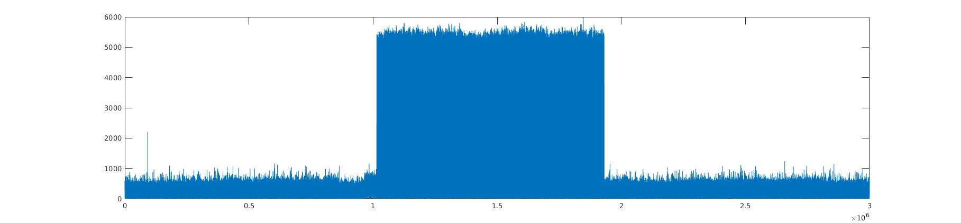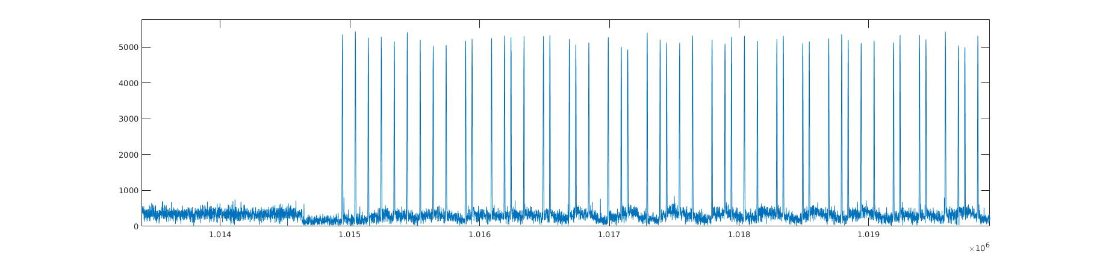

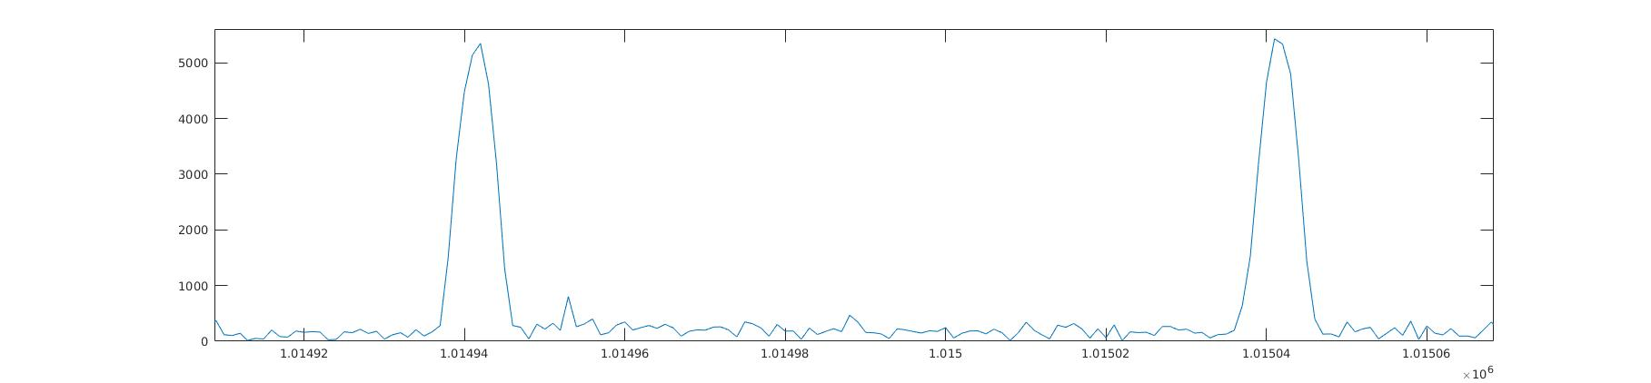

You will need to convert symbols after the preamble to binary data. To simplify the problem, in this project, the signal is much stronger than noise.

1. You will need to use the samples at the beginning (I used the first 10,000 samples) to learn the statistics of the noise, i.e., the mean and standard deviation, with which you can select a threshold for pulse detection. I used mean * 8 + standard_deviation * 16 as the threshold.
2. You will need to find the boundary of the symbols. You should use the preamble symbols for this purpose. The first symbol in pj1_testsignal1 should start at sample 1014939, give or take one or two, depending on the threshold you use. Please note that the symbol does NOT start at the first sample.

After getting all the bits, to process the binary data:

1. For every 7 bits, take the first 4 bits and discard the remaining 3 bits.
2. For every two 4-bit segments, combine them into one byte. For example, “0010” and “1010” will be combined as “00101010,” where the left most bit is the most significant bit.

(The binary data is organized in a way related to Project 2, therefore may appear somewhat strange for now.)

­­You will need to treat the byte stream as a plain text string. You can print it as a string and it should give you “Zhenghao Zhang received his B.Eng. and M.S. degrees in electrical engineering from” and so on.